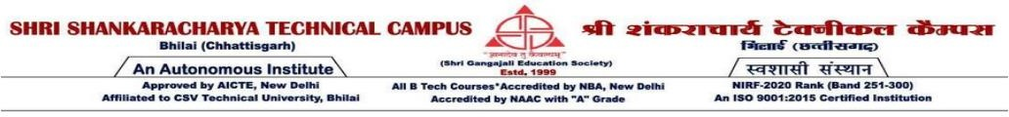

**Progress Report 1:** Project Introduction and Initial Research

**Title: Hand Gesture and Sign language Detection.**

# Submitted by:

* **Anurag Kumar (301410921040)**

# Ashutosh Raja (301410921070)

* **Masoom (301410921075)**

**Date:** 04/11/2024

**Day:** Monday

# Project Overview

The aim of this project is to design and develop a real-time Sign Language Detector using computer vision techniques, particularly hand gesture recognition. The system leverages OpenCV for image processing and python-based machine learning frameworks, to recognize hand gestures and translate them into readable text. MediaPipe is used to efficiently track hand movements, making the system capable of recognizing various gestures in real-time.

# Objective and Scope

The primary objective of this project is to design and develop an intelligent, real-time Sign Language Detection system that translates hand gestures into readable text, enabling effective communication for the deaf and hard-of-hearing communities. Utilizing computer vision techniques, particularly hand gesture recognition, this project leverages OpenCV for image processing, MediaPipe for efficient hand tracking, and machine learning algorithms to achieve accurate and responsive gesture recognition in real-time.

# Machine Learning Models for Prediction:

We are exploring algorithms such as Linear Regression, Decision Trees, Random Forest, and Support Vector Machines, along with deep learning techniques like LSTM networks for time series predictions. We are evaluating these methods to optimize our model's accuracy.

# Model Evaluation and Metrics:

Model performance is assessed using metrics like Mean Absolute Error (MAE), Root Mean Squared Error (RMSE), and R-squared values, enabling us to compare models and select the most accurate for our dataset.

# Next Steps

Next steps in our project are as follows:

**Data Collection**: Identify and collect sign language data.

**Data Preprocessing**: Clean and preprocess the data for model training.

**Model Selection**: Start with simple models for baseline performance before exploring more complex ones.

# Challenges and Considerations

Anticipated challenges include managing large datasets, handling missing values. Computational resources may also limit the training of advanced models.

This report establishes the project foundation, outlining its scope and initial steps. Subsequent reports will focus on data preprocessing, model building, evaluation, and refinement.

**Guide Name:** Neha Choubey

# Guide Signature: